**How to Install a Custom TF2 HUD**

Boris Russanov

October 7, 2020

**TF2 Custom HUD 1**

**Table of Contents**

Figures……………………………………………………………………………………………………………………………………….1  
Background..………………………………………………………………………………………………………………………………2  
Abbreviations.……………………………………………………………………………………………………………………………2  
Preparations and Setup………………………………………………………………………………………………………..……3  
 1. Ensure the Operating System has TF2 Installed………………………………………………………………….3  
 2. Check Computer Storage and Operating System……………………………………………………………….3  
Installing The HUD……………………………………………………………………………………………………………………..4  
 1. Find a HUD of Preference…………………………………………………………………………………………………..4  
 2.Navigate to Files and Directories………………………………………………………………………………………..5  
 3.Check Out The HUD…………………………………………………………………………………………………………….6  
References…………………………………………………………………………………………………………………………………7

**Table of Figures**

Figure 1 – PC Storage....….…………………………………………………………………………………………………….…..3  
Figure 2 – HUDS page.……………………………………………………………………………………………………………….4  
Figure 3 – HUD description………………………………………………………………………………………………………..4  
Figure 4 – Extract File…………………………………………………………………………………………………………………5  
Figure 5 – Properties………………………………………………………………………………………………………………….5  
Figure 6 – Properties Tab…………………………………………………………………………………………………….…….5  
Figure 7 – TF Folder……….………………………………………………………………………………………………..….…….5  
Figure 8 – Custom with HUD……………………………………………………………………………………………….…….6  
Figure 9 – HUD Old…………………………………………………………………………………………………….………….….6  
Figure 10 – HUD New……………………………………………………………………………………………….………..……..6

**TF2 Custom HUD 2**

**How to Install a Custom TF2 HUD**

**Background**

This instruction manual serves as thorough guide on how to install a customized HUD in the video game *Team Fortress 2*™, made by Valve [1]. For this manual to be useful, it is best to have the game, TF2, installed and a basic understanding of how to use the Windows operating system. It is not necessary to understand how the files in the HUD operate. We are focusing solely on the folder directory of the TF2 HUD installation. Through the installation of this HUD, you will be able to understand the basics of file downloads and folder locations.

**Abbreviations**-TF2: Team Fortress 2 (game)  
-Hud: Heads Up Display

**TF2 Custom HUD 3**

**Preparations and Setup**

**1. Ensure the Operating System has TF2 Installed**

Go into your Steam library to check if you have TF2 installed. Open Steam and look in your library. Check if you can run the game. If you cannot, download it for free on the Steam store page.

**2. Check Computer Storage and Operating System**

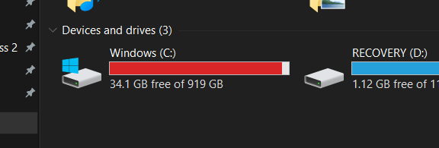In this case, we will be installing the TF2 HUD   
on a Windows operating system. Check the computer storage by clicking on the folder icon  
and then “This PC”. Make sure you have at least   
a few gigabytes in storage before downloading a custom HUD, as shown in Figure 1.  **Figure 1 – PC Storage**

**TF2 Custom HUD 4**

**Installing the HUD**

**1. Find a HUD of Preference**

The HUD we are installing for this guide only serves as an example and does not necessarily have to be the same as your HUD. It is best to choose a HUD that you personally like based on the preview images.

1. Navigate to the huds.tf [2] website (or any other TF2 HUD-sharing page). The website page is shown in Figure 2.

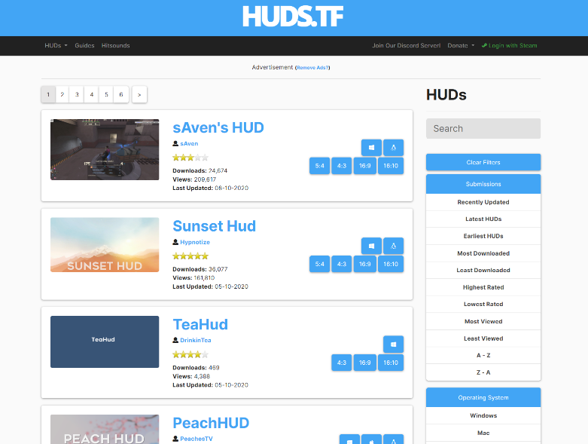

**Figure 2 – HUDS page**

2. Install a custom HUD from the site. For this manual, we will be downloading Hypnotize’s *SunSet Hud*. As mentioned in step two in preparations and setup, make sure you have enough storage to download the HUD and is supported for your system, as shown by arrows in Figure 3.

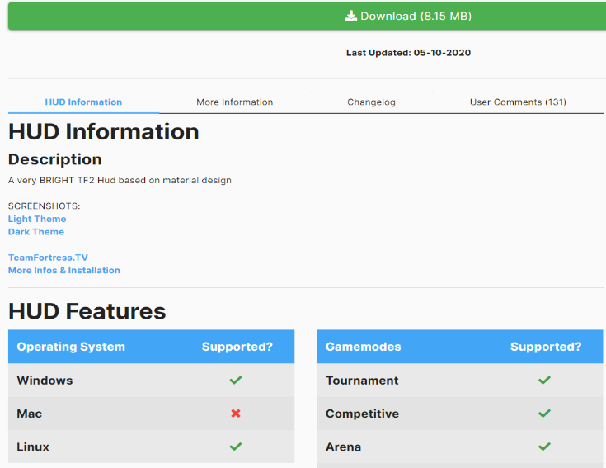

**Figure 3 – HUD description**

**TF2 Custom HUD 5**

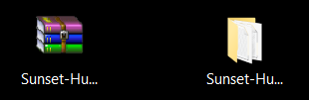**2. Navigate to Files and Directories**

1. After you install the zip file to your preferred folder, extract the file with Windows Explorer and save it. The extraction of file is shown in Figure 4.

**Figure 4 – Extract File**

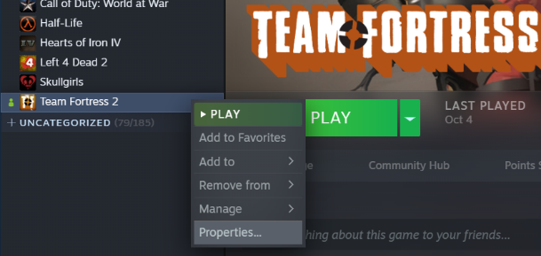

2. Locate your TF2 folder by right-clicking   
the TF2 icon in Steam and select properties,   
as shown in Figure 5.

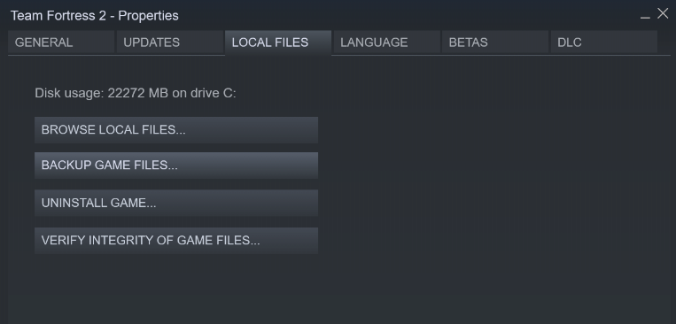 **Figure 5 – Properties**

3. In the properties window,   
click on the “Local Files” tab   
and then click “Browse Local Files…”  
which will open the “Team Fortress 2”  
folder. The tab is shown in Figure 6.

**Figure 6 – Properties Tab**

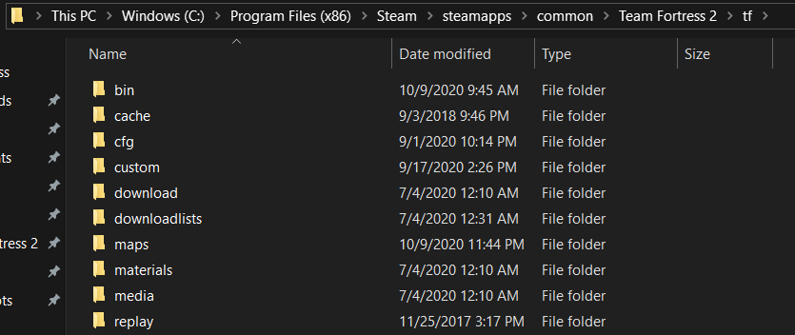



4. Open the “tf” folder. Inside there  
should be a “custom” folder. If there  
is not one, press right-click and create a new folder and title it “custom”,  
as demonstrated in Figure 7.

**Figure 7 – TF Folder**

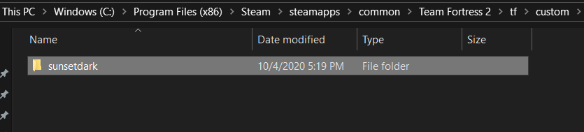**TF2 Custom HUD 6**

5. Get the extracted file from step one   
and place the file into the “custom” folder.  
For this case, the author put the HUD file  
inside the main folder we extracted so we  
will put “sunsetdark” into “custom”, as seen  
in Figure 8.

**Figure 8 – Custom with HUD**

**3. Check Out The HUD**

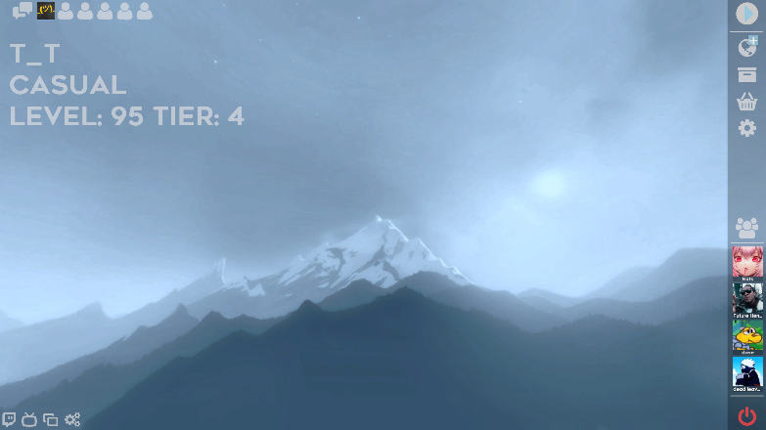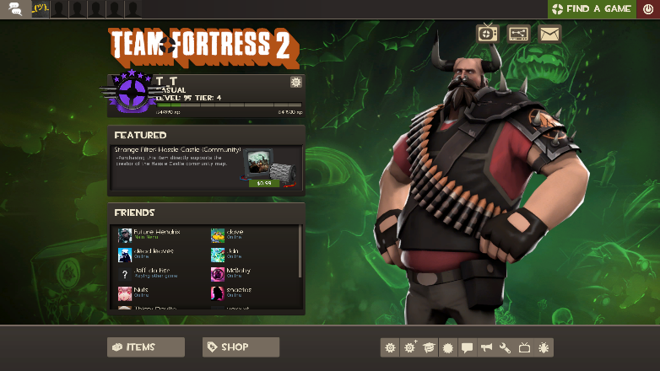1. Launch TF2 through Steam and check if the new HUD works.

**Figure 10 – HUD New**

**Figure 9 – HUD Old**

Now you have installed a Custom HUD!

**TF2 Custom HUD 7**

**References**

[1] <https://www.valvesoftware.com/en/>  
[2] <https://huds.tf/>